**Exercise**

Develop a simple web based application to retrieve data from Server and display the results on the Front end. The Front-end should look like or closer to UI Mock ups.

Refer attached CSV files for data structure and UI Mock Up images with below instructions to understand the requirements.



**Data base** scripts for MS SQL and SSIS

* Produce a script to create database objects to hold the data in the provided sample CSV file.
* Create a simple SSIS project (target 2017) to load the CSV files provided into DB tables.
* Create stored procedures to retrieve data from the tables to populate the sample screens

**Server side** to be developed usinag .Net version >= 4.5 or .Net core version >= 3.1

* Create Controller/ Web API method named ‘GetData’ which returns proposals data from Data base
* Implement simple and suitable error logging. (Optional)
* Include some Nunit tests for services/controller methods. (Optional)

**Client side** to be developed using React JS, HTML and CSS.

* On Click of “Get data” button, call server’s controller method ‘/GetData’ and display retrieved data on Data grid (use any 3rd party Data grid of your choice from npm packages)
* On click of “View summary” display facilities details in a summary panel below the row as shown in 2nd mage in UI Mock Ups, if there are no facilities then display message “No facilities found”.
* On Change of Facility dropdown refresh the details below facilities dropdown in the summary panel. (Optional)

UI Mock ups:

UI Mock of data grid showing proposals.

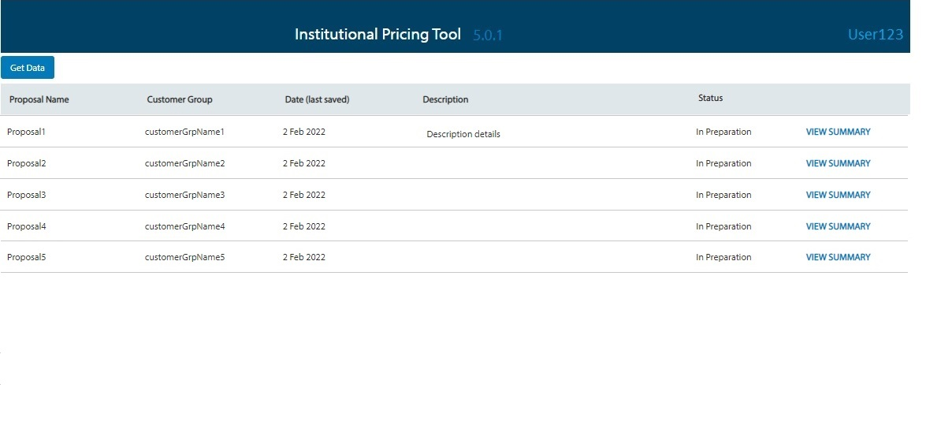

UI Mock of summary template expanded on click of View summary.

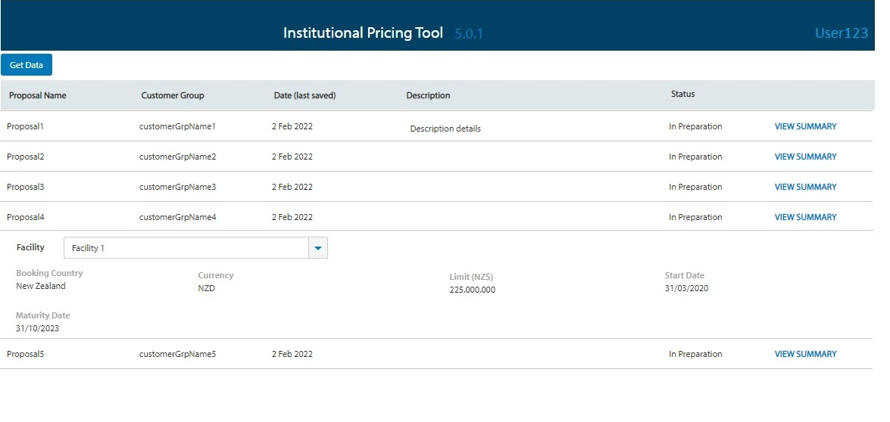

**Instructions to send source code**

Include any relevant instructions required to compile and run code in a text file.

Upload the .dtsx file, DB scripts and website source code on GitHub

Host the website on GitHub and send us the links.